Act Report

* **Introduction :**

Data Wrangling, Analysis and Visualisation are critical skills that are necessary in the handling the challenges in a variety of modern-day data-driven businesses.

For this project we used a database called WeRateDogs Twitter archive, which contains a Twitter account called @dog_rates that posts tweets about rating dogs and their photos.

* **Analyzing and Visualizing Data :**

In this step, I analyze and visualize wrangled data, I produced three insights and two visualization, which are as follows :

Insights:

1.The percentage of dog types : doggo, floofer, pupper and puppo.

2.Top 5 name that write tweet.

3.The most tweet has been retweet.

Visualization:

1. In this visualization, we have the types of dogs and they are divided into four types doggo, floofer, pupper and puppo. We showed it in the pie chart, where it shows us the frequency of each type of dog.

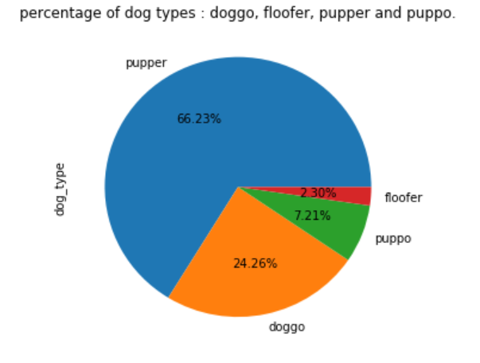

It turns out that the most type of dog is pupper by 66.23% then is doggo by 24.26% then is puppo by 7.21% and the last is floofer by 2.30%.

1. In this visualization, we have the top five dog names that were repeated in tweets and were displayed using a bar chart.

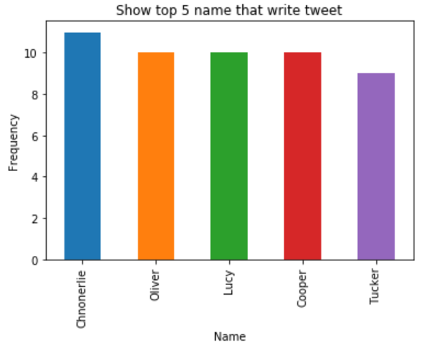

It turns out that the highest dog name repeated is Chnonerlie then followed Olive, Cooper, Lucy at the same level and the last name is Tucker.

* **Conclusion :**

In the end, some data was analyzed and visualized, but there is a lot of it to analyze and visualize.

Maryam Alablani